[Insert vessel name]
Safety Management System
[Insert Master Name)
ABN: [Insert ABN]

DOCUMENT SCOPE

(insert name of author] have produced this document for [Insert name and address of vessel Owner/Master]. This document has been produced using the AMSA resources available as at [insert date of development).
This document was compiled to assist [Insert name of Vessel Owner/Master]implement a safety management system (SMS) that meets the requirements of Marine Order 504( Certificates of Operation and operation requirements-national law) 2018 for the vessel [Insert vessel name] for diving operations used in the Abalone fishery in Western Australia.
LIABILITY FOR USE
The information in this document is given in good faith and is based on the knowledge and experience of those professionals who contributed to the document in the field of expertise in health and safety.
Any changes made to this template are at the discretion of the author and or Vessel Owner and Master.
Fishsafe Australia shall not be liable for any loss, damages or other claim in respect of or arising from any death of or injury to or damage to property of any person which may occur while any person conducts any fishing activities concerned with these guidelines.

Contents
INTRODUCTION 2
1. VESSEL AND OPERATION 3
1.1 Company and vessel details 3
1.2 Risk Assessment 4
1.3 Maintenance of vessel and equipment 10
2. PEOPLE 11
2.1 Owners, masters and designated persons responsibility and authority statements 11
2.2 Resources and personnel 13
3. POLICY’S AND PROCEDURES 14
3.1 Vessel Policy’s 14
3.2 Vessel Procedures Overview 15
3.3 Standard operating procedures 15
PRE- OPERATION/FISHING 15
Trailer Hook Up 15
Pre-Tow Checks 15
Pre-Trip Checks 15
Crew Briefing 16
Launching & Recovery 16
Embarking / Disembarking 16
Loading / Unloading 16
3.4 Emergency preparedness 19
3.5 Hazardous occurrences and non-conformances 19
3.6 Documentation 21
3.7 Review and evaluate 21
Appendix 1: Emergency procedures 23
Appendix 2: Dangerous Species First Aid 29
Appendix 3: Pre-Departure Checklist- and scheduled maintenance 33
Appendix 4: Pre-Departure Checks 34
Appendix 5: Maintenance Log 35
Appendix 6: Crew Induction checklist 36
Appendix 7: Master/ Crew training register 37
Appendix 8: Approved Crew List 38
Appendix 9: Emergency drill record 38
Appendix 10: Vessel logbook 39
Appendix 11: Incident Register 40
Appendix 12 Revisions & Annual Review Page 40

INTRODUCTION

The information in the SMS is broken down into the following categories:
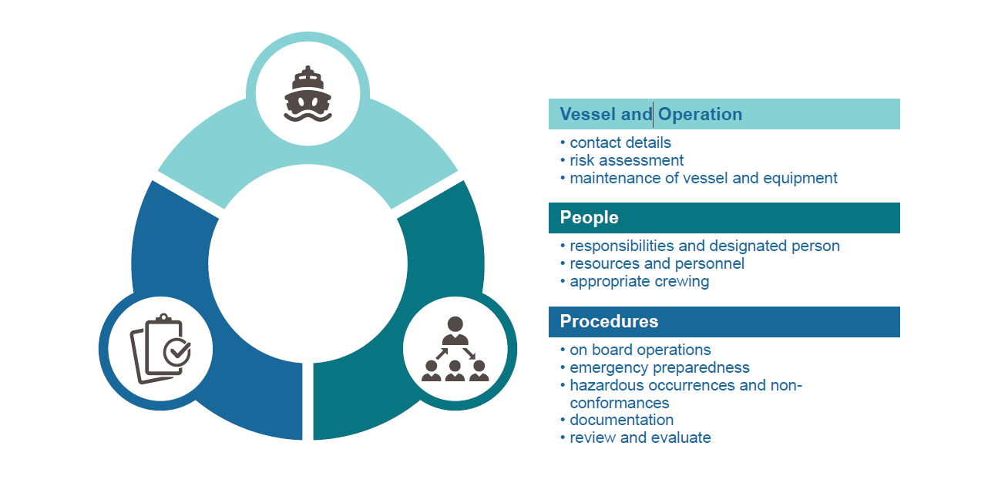
The implementation of this SMS for the vessel [Insert Vessel Name] will result in:
- An increased awareness of potential safety issues, operational risk and opportunities for improvement
- A better understanding from crew in how safety is managed and communicated on your vessel
- More informed decision-making
- Good business practice

VESSEL AND OPERATION

1.1 Company and vessel details

Vessel details
Vessel name: |  |  |  |  | Unique Identifier number
Vessel type: |  |  |  |  | Vessel length
Year of build: |  |  |  |  | Vessel draught
Hull material: |  |  |  |  | Service category:
Propulsion power: |  | Main make & kilowatts |  |  | Auxiliary make & kilowatts |  |  | Serial numbers
Passengers: |  | Berthed |  |  | Unberthed |  |  | Special persons
 |  | 0 |  |  | 0 |  |  | 0
Special conditions, exemptions:
Classification society
(if applicable)
Licence details:
Vessel complement
Certified crew number: |  |  |  |  | Uncertified number: |  |  | 0
Crew and qualifications
Master |  | Engineer |  |  | GPH |  |  | Deckhand
Operation summary
Operating area |  |  | Activity |  |  |  | Voyage duration
Contact details
Item | Name/ABN/CAN |  |  | Address |  | Telephone (24hrs) |  |  | Email
Company:
Vessel owner:
Designated person:
Master/skipper

1.2 Risk Assessment

(a) Identifying the risks
The risk assessment is the foundation of this SMS. It identifies daily tasks, emergency situations and risk to this vessels operations that need to be controlled and managed for this vessel.
A risk includes anything that may pose a hazard to people (both on and off the vessel), property (the vessel, cargo, or other structures), or the environment. It can also include financial or reputational risks.
A risk assessment will be reviewed on an annual basis within the risk register or similar, and identify all the vessels key operational tasks and how they are controlled — the procedures of who, what, when and how.
The Risk Register as shown on pages contains the risk assessment conducted for this vessel.
(b) Managing the risks
Once you have identified the risks, consider what you do to address the risk. These measures are called 'controls'. Review and add effective controls for each key daily task.
You need to implement the controls and they need to form part of the procedures and emergency plans.
The risk assessment is based on the best possible information relating to reasonably practical; measures and best practice.
(c) Risk Tables
Likelihood of occurrence
Likelihood | Description
Highly unlikely | Could happen but probably never will (Rare situation)
Unlikely | Could happen but only rare
Likely | Could happen occasionally
Rare | Could happen frequently
Consequence
Consequence | Description
Major | Permanent disabling injury /death
Serious | Medical treatment requiring several days off work/hospital treatment as in in patient
Minor | First aid / medical treatment
Insignificant | No injuries

Risk Rating Matrix
(d) Risk Treatment / Control Rating
The following methodology to assist with determining if controls are needed and if so whether they have sufficiently reduced the risks.
 | LIKELIHOOD
CONSEQUENCE | Very Likely | Possible | Unlikely | Rare
Major | High | High | High | Medium
Serious | High | High | Medium | Medium
Minor | High | Medium | Medium | Low
Insignificant | Medium | Medium | Low | Low
(d) Risk Treatment / Control Rating
You assess the risk level before controls are addressed and again after. If the remaining risk level is still high review the control again and see what can be done?

Risk Rating | Description
Low | You and your crew should be aware
Medium | You should make changes to improve and lessen the risk
High | You should stop the operation until you can make substantial changes to the operation
Acceptable Risk
Reasonably practicable measures must be taken to maintain the risk level within the acceptable range.
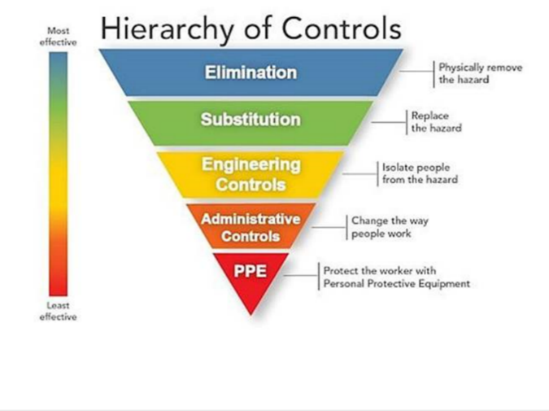
Risk Control Methods

(e) Risk Register Activity / Hazard

 | Risk (What could go wrong) | Likelihood (without controls) | Consequence (without controls) | Risk Rating | Controls | Likelihood | Consequences | Risk Ratings
PRE - FISHING
Crew Selection | Inappropriate or unqualified personnel | Possible | Major | High | - Approved Crew List – only use crew from the Approve Crew List whom qualifications are current.  - Select Core Complement or Appropriate Crew according to the Vessel, Area of Operation & Type of Activity.  - Crew Training and Induction | Possible | Minor | Medium
Crew Training & experience | Personal injury, Disruption to operations | Possible | Serious | High | - Initial Safety Training  - Operational Training  - Emergency Procedure Drills | Unlikely | Minor | Low
Trailer Hook Up | Injury / Damage | Possible | Serious | High | - SOP – Trailer Hook Up | Unlikely | Minor | Medium
Towing | Trailer separation, boat separation, collision with other vehicles. | Possible | Serious | High | - SOP - Pre-Tow checks completed and marked off on the Vessel Log.  - Ensure Driver is fit for work  - Stay alert and drive to the conditions | Rare | Major | Medium
Vessel Preparedness | Insufficient fuel / oil, Missing / damaged equipment, mechanical failure, Vessel Suitability | Possible | Major | High | - SOP - Pre-Trip Checks completed and marked off on the Vessel Log  - Routine Maintenance.  - Programmed Inspection & Maintenance. | Unlikely | Serious | Medium
Launching / Recovery | Collision with person or objects, slip on ramp, premature boat release, damage injury | Possible | Serious | High | - SOP – Launching & Recovery | Possible | Minor | Medium
Embarking / Disembarking | Vessel moving against wharf / Jetty: Slips, falls & crush injuries | Possible | Major | High | - SOP – Embarking / Disembarking | Possible | Minor | Medium
Loading / Unloading | Manual handling injuries | Possible | Minor | Medium | - SOP - Loading / Unloading | Rare | Minor | Low
Vessel Operations
Weather Monitoring | Get caught in severe weather and/or ocean conditions. | Possible | Serious | High | - SOP Weather Monitoring  - SOP Crew Briefing | Possible | Minor | Medium
Navigation | Collision: other vessels, underwater obstacles, grounding | Possible | Major | High | - Approved & qualified crew  - Keep a look out  - Use GPS and Depth Sounder to assist | Unlikely | Serious | Medium
Anchoring | Personal injury, dragging. | Possible | Minor | Medium | - SOP Anchoring  - Emergency Procedures (Diving) | Unlikely | Minor | Low
Working Close to Reefs | Damage to Vessel, Grounding | Possible | Serious | High | - SOP Working Close to reefs  - Policy PFDs  - Emergency Procedures (Grounding)  - Approved & qualified crew,  - Operational Training. | Unlikely | Serious | Medium
Breaking Waves | Injury, loss of life, damage to vessel | Possible | Major | High | - SOP Breaking Waves  - Policy PFDs  - Approved & qualified crew | Unlikely | Serious | Medium
Capsizing | Injury, loss of life, Severe Damage, | Possible | Major | High | - SOP Capsizing  - SOP Breaking Waves  - Policy PFDs | Unlikely | Serious | Medium
Worker Fatigue | Impaired performance, injury, reduced productivity | Possible | Major | High | - Fatigue Management Policy | Unlikely | Serious | Medium
Alcohol & Drugs | Impaired judgement, personal injury. | Possible | Major | High | - Alcohol & Drugs Policy | Unlikely | Minor | Medium
` | Sunburn, dehydration, heat stress | Possible | Major | High | - Pre-Trip check (Water, PPE on board)  - Stay in shade as much as possible  - Awareness of signs & symptoms of dehydration. | Possible | Minor | Medium
Working in Cold Environments | Hypothermia through exposure | Possible | Major | High  12 | - PPE including wet weather gear.  - Stop if conditions are unsafe | Possible | Minor | Medium
Electrical | Electric shock from generators | Possible | Minor | Medium | - Leads to be kept off the ground and dry | Rare | Minor | Low
Environmental impact | Littering, oil spills, pollution. | Possible | Major | High | - Environmental Procedures | Unlikely | Minor | Medium
Mechanical Failure | Mechanical breakdown | Possible | Serious | High | - Scheduled servicing is conducted by qualified service agents, records kept by the service agent and also noted in the maintenance register.  - Daily inspection and maintenance is carried out by the Master and recorded on the Vessel Log. | Unlikely | Minor | Medium
Hazards Material & Liquids | Wrong oil use in compressor or air pump, ingestion – poisoning. | Possible | Serious | High | - Correct storage of liquids.  - Decanted oils /liquids MUST be properly labelled.  - Material Safety Data Sheets to be attached to this SMS  - Emergency Procedures (Medical) | Rare | Serious | Medium
Emergencies | Fire  Person Overboard  Medical Emergency  Collision  Grounding  Flooding  Severe Weather  Diving emergencies | Possible | Major | High | - Emergency Preparedness Plan  - Policy PFDs  - Training – Emergency Drills  - Vessel Survey Equipment  - Maintain proper look out | Possible | Serious | Medium
Re-fuelling | Fire, explosion or spills | Possible | Major | High | - SOP Re-fuelling. | Rare | Major | Medium
Fishing /Diving Operations
Abalone Diving | Decompression Illness,  Hypothermia,  Gas poisoning,  Entrapment,  Fouled Umbilical,  Bites & Stings, | Possible | Major | High | - Industry Standard for Abalone Diving  - Dive to AS /NZS 2299.1 (2015)  - SOP Pre-Dive Checks  - Emergency Procedures (Medical, Diving) | Unlikely | Serious | Medium
Winch / Davit | Injury from winch handle, swinging load | Possible | Serious | High | - SOP Winch / Davit  - Training of crew | Unlikely | Serious | Medium
Compressor | Burns, amputation, mechanical failure | Possible | Serious | High | - SOP Compressor  - Belt guard in place  - Training of crew  - Emergency Procedures (Diving) | Unlikely | Minor | Medium
Catch handling | Injury from sharp knives, chippers, spines, stings. | Possible | Serious | High | - SOP Catch handling  - PPE on board  - Training of crew | Unlikely | Serious | Medium
Other Vessels | Diver could get run over. | Possible | Major | High | - SOP Other Vessels  - Dive flag erected | Unlikely | Serious | Medium
Working Live | Diver could get run over, Airline cut. | Possible | Major | High | - SOP Working Live  - Operational Training  - Policy PFDs  - Approved crew  - Emergency Procedures (Diving Emergency) | Rare | Major | Medium
Shark or Marine Mammal | Animal bite or entanglement | Possible | Major | High | - SOP Sharks  - Emergency procedures (Diving Emergency)  - Shark repellent devoices | Unlikely | Major | Medium

1.3 Maintenance of vessel and equipment

[Insert Vessel Name] has a number of processes to provide for the effective maintenance of the vessel and its equipment and these are detailed below:
The Owner of the Vessel is responsible for ensuring that Routine and Programmed Inspection & Maintenance is being carried out.
Running repairs, minor servicing, correction of faults and replacement of equipment shall be carried out by the Master, appointed crew or qualified service agent at the end of each days fishing operation
Scheduled Maintenance shall be carried out in accordance with the Maintenance Schedule (Appendix 3) Details of work performed by qualified service agents are recorded on the job sheet retained by the service agent.
- Pre-departure checks carried out by the Master and Crew prior to each voyage( Refer to Appendix 3 and 4 for template)
- All records can be maintained in Appendix 5 – Maintenance Log

PEOPLE

2.1 Owners, masters and designated persons responsibility and authority statements

(a) Owner Details | The person with overall general control and management of the vessel. This may be the operator of the vessel and not the company or other person that owns the vessel.
Duties: | - Determining the appropriate crew for each type of operation.  - Ensuring that scheduled and routine maintenance is carried out.  - Conducting the Annual Review of this SMS, all documents and records.  - Develop , maintain , review and improve the vessel SMS  - The supply and maintenance of marine safety equipment on-board  - Maintaining the vessel as fit for purpose  - Ensuring the master conducts instruction, training and supervision of crew/persons on-board the vessel  - Ensuring the vessel stores and associated supplies are sufficient for intended voyages
Name:
Address:
Phone number:
Email address:

(b) Master Details | The Person usually in command of the vessel. The owner may appoint themselves as the both the designated person and the master
Duties: | - Command of the vessel and its safe operation.  - Implementing and complying with the SMS including:  - Delivery of crew training and induction  - Taking timely and reasonable measures to eliminate or effectively control any risk that is identified.  - Maintaining the vessel’s logbook  - Investigating risks and implementing controls  - Implementing and complying with the SMS  - Maintenance of the vessel, its safety equipment and machinery  - Commercial operations  - Delivery of crew training, familiarisation and inductions  - Maintaining the vessel’s documentation  - Command of the vessel and its safe operation  - Compliance to regulations.
Name:
Address:
Phone number:
Email address:

(c )Designated Person | The Owner must designate a person with direct access to the owner to be responsible for monitoring the safety and pollution prevention of the vessel and ensuring appropriate resources and shore support are provided to the vessel.  The Owner may appoint him or herself as the Designated Person.
Duties: | - Conduct pre-departure checks  - Monitoring the safety and pollution prevention of the vessel,  - Ensuring appropriate resources and shore support are provided.
Name:
Address:
Phone number:
Email address:

[Insert Vessel Name] Organisational Chart

2.2 Resources and personnel

(a) Crewing arrangements
The appropriate crew determination forms part of the Risk Assessment in Section 1.2 as part of pre-fishing.
(b)Appropriate Crew
“Appropriate Crew” is the level of crew required for carrying out normal fishing operations.
After consideration of the design characteristics of the vessel, safety equipment on board, the Emergency Preparedness Plan, Risk Assessment, Area of Operation and Type of Activity; the Owner and Master have agreed on the appropriate crew to safely run the operation as set out in the table below.
After consideration of the design characteristics of the vessel, safety equipment on board, the Emergency Preparedness Plan, Risk Assessment, Area of Operation and Type of Activity; the appropriate crew to safely run the operation as set out in the table below.
Area of Operation | Type of Activity | Core Complement &Qualifications | Appropriate Crew & Qualifications

(b) Crew training and qualifications
Upon joining the Vessel and prior to commencing duties for the first time, a crew member MUST complete the Initial Safety induction.
The crew induction program in relation to the vessel is contained in Appendix 6.
The Master of the vessel, will provide all training and induction. All training, induction and drills ill be recorded in Appendix 7 – Master/Crew Training register.
The Master and Crew details list is located in Appendix 8 which contains the contact details of each crew member.
There will be at least 1 person on board the vessel with a current first aid qualification.
Al crew records are maintained in the [Insert Business/vessel name] principal place of businesses detailed in Appendix 8.
The Owner of the vessel shall ensure that each crew member receives the following training. The training must be given by the Master or by a crew member who the Master considers has the skills and knowledge to provide the training. All training shall be recorded in the Appendix 7 – Master/Crew Training register.

3. POLICY’S AND PROCEDURES

3.1 Vessel Policy’s
The key policy’s that apply to the [Insert Vessel Name] that address all business activities are listed below:
PFDs (Personal Floatation Devices)
- A PFD shall be issued to each crew member prior to commencing duties for the first time.
- A PFD shall be worn by each crew member in the following circumstances:
- In the event of the following Emergencies; Abandon Ship, Severe Weather or Flooding.
- At times of heightened risk as defined below:
- Crossing or attempting to cross an ocean bar or operating within a designated hazardous area.
- When the vessel is being operated during a period of restricted visibility.
- When working close to reefs where there is a medium or high risk of grounding.
- When working close to breaking waves where there is a medium or high risk of capsize or flooding.
- When working in rough conditions where there is an increased risk of entering the water unexpectedly
- If conditions have changed and the crew deems it prudent to don a PFD.
- At any time when instructed by the Master to do so.
Communications
- All persons on board are always under the authority of the Master and must adhere to the Masters directions.
- The Master must communicate with Crew in a clear and concise manner.
Fatigue Management
- Maximum shift length including travel shall be 12 hours with regular breaks as required.
- Crew must present “Fit for work” meaning well rested and free of the influence of drugs & alcohol.
- Diving exposure to be kept as low as reasonably achievable.
Alcohol & Drugs
- No Alcohol is permitted to be consumed or brought on board the vessel on a work day.
- No Alcohol is to be consumed by the Diver within 8 hours before diving.
- The abuse of illicit and medicated drugs or being in possession of illicit drugs whilst working is strictly prohibited.
- Persons under the influence of alcohol or drugs shall be considered unfit for work and must be immediately returned to shore and removed from the worksite.
- Smoking is only permitted during breaks in an area away from the compressor air intake and away from any fuel and oil containers.
- All butts will be placed in a wet metal bucket or tin, and then disposed in the garbage bin provided.
Behaviour & Conduct
- All crew members must conduct themselves in a professional, responsible and safe manner at all times. Irresponsible behaviour must be discouraged. Showing off, acts of bravado or anything else involving risk taking contrary to safety standards should be stopped immediately and the potential danger of the actions explained.
Environment
- All plastics and rubbish shall be retained on board, placed in a garbage bin or bag and disposed of properly on return to port.
- Re-fuelling of the Vessel shall only take place on shore.
- Any major release of oil or fuel on land or water shall be reported immediately
Diving Work
- Divers are medically fit and competent through qualifications and/or experience for the type of diving work being carried out.
- A dive supervisor with the required level of competence is appointed to supervise workers carrying out general diving work.
- A dive plan is prepared by the dive supervisor.
- A dive safety log is prepared.

3.2 Vessel Procedures Overview
Key on board operations are contained in the risk assessment and are documented in this section.
Key on board operations can include:
- Those operations connected to the vessel's which may affect safety and pollution prevention
- Those operations which the master considers higher risk if not appropriately controlled
- Those operations for which safe practices in vessel operations and safe working environments have been recommended by AMSA and other relevant marine industry bodies
- Other operations prescribed in mandatory rules and regulations.
- In addition, the controls and management process identified in the risk assessment must be documented to demonstrate they are carried out safely.

3.3 Standard operating procedures
These standard operating procedures relate to the items listed in the Risk Register

PRE- OPERATION/FISHING

Trailer Hook Up
- Use a crew member to assist with hook – up.
- Driver to maintain visual contact with the assisting crew member.
- Keep other people well clear.

Pre-Tow Checks
- Trailer Coupling - seated on the tow ball correctly, the coupling handle is down and latch secured.
- Safety Chain(s) – attached to the vehicle using correctly rated shackles.
- Break A-Way Cable – attached to vehicle.
- Trailer Lights – connected and working.
- Winch Cable – connected and secure.
- Vessel Safety Chain – connected

Pre-Trip Checks
- Hull Inspection – the Vessel has no obvious damage
- Bung(s) – are in and sufficiently tightened.
- Radio Aerial – Up
- Battery(s) – turned on
- Vessel Fuel & Oil – levels are sufficient for the day’s operations and contingencies.
- Compressor Fuel & Oil – levels are sufficient for the day’s operations and contingencies.
- Safety Equipment – on board the vessel
- Dive Equipment – on board the vessel.
- Fishing equipment (Bins, Tags, etc.)
- Documents (Docket books, Licences, Vessel Log) – is on board
- Radio – is working
- Engine & Controls – secure, operating correctly.
- Gauges – working and within acceptable operating range.
- Davit – ratchet, pulley & rope in good working order.
- Bilge Pump / scuppers – not blocked, working.
- Sufficient food and drinking water - on board the vessel.
- PPE (Hats, protective glasses, protective gloves, sunscreen, wet weather gear) – on board the vessel.
- Securely stow all equipment for safe travel.
- Conduct Crew Briefing

Crew Briefing
- Discuss the weather forecast, ocean conditions, planned fishing location and operations with all crew members.
- Assess any Heighten Risks, the need to don PFDs
- If there is an Extreme Risk of getting caught in severe weather, grounding, capsizing, flooding or P.O.B.; cease fishing operation immediately and take appropriate action.

Launching & Recovery
- Ramp - Inspect the ramp, water and turning space for people & obstacles before launch or retrieve.
- Look Out - Use a crew member to assist & supervise.
- Keep all people well clear of the back of the vessel and vehicle.
- No person is to place any part of their body between any fixed or moving components.
- Safety Chain – remains connected to vehicle at all times.
- Be aware of slippery surfaces and take precautions.

Embarking / Disembarking
- Ensure Vessel engine is in neutral and not moving excessively.
- Use appropriate grab rails or grab points.
- Apply the “three points of contact” rule.
- Keep hands and feet clear of the gunwale & jetty or wharf.

Loading / Unloading
- Use correct manual handling techniques.
- 2 person lift for heavy loads.
- Slide bins around the deck in preference to lifting.

VESSEL OPERATIONS
Weather Monitoring
- Check weather forecast and sea conditions prior to launch.
- Constantly monitor changes in weather and ocean conditions through observation.
- Select appropriate fishing location based on prevailing conditions and forecasts.
- If conditions deteriorate significantly, conduct 5.4 Crew Briefing and/or return to port

Working Close to Reefs
- Maintain a proper look out at all times
- Visual observation and Depth Soundings are to be monitored
- If the Anchor is deployed, check holding status regularly.
- Wave, wind and tidal changes are to be monitored.
- PFD’s must be worn by all crew when working where there is a medium or high risk of grounding on a reef

Breaking Waves
- Whenever possible AVOID locations near breaking waves.
- PFD’s must be worn by all crew when working where there is a medium or high risk of capsize or flooding due to breaking waves.

Capsizing
- Keep scuppers free from obstruction (self-draining deck).
- Operate bilge pump regularly to prevent build-up of water on the deck.
- Stow the load (catch, bins & equipment) so that it does not compromise stability nor shift greatly during travel.
- Do not exceed load limits of the vessel.
- Ensure that EPIRB and life rings are able to be deployed in the event of a capsize.
- PFD’s must be worn by all crew when working where there is a medium or high risk of capsize.

Re-fuelling
- Re-fuel the Vessel on shore (day boat) or for overnight trips at sea, when vessel is stable (limited rocking motion).
- Minimise the number of crew on board during re-fuelling.
- Follow standard safety precautions as prescribed by the filling station.

Anchoring
- The vessel is fitted with a sand & reef combination Anchor.
- The anchor is deployed & retrieved from the bow of the vessel and secured to the bow line.
- Anchor, chain & rope is stored and fed from the anchor bin or gunwale pocket.
- Deploy sufficient anchor rope to ensure that the anchor will hold, considering the substrate and wind strength.
- Care is taken to ensure the anchor line does not become entangled when being deployed.
- If the anchor gets stuck, the anchor line may be tied off on a cleat and the movement of the vessel used to dislodge the anchor. Keep hands well clear of the anchor line and the tie off point.
Mooring
- Crew to have grapple and rope attached, ready before coming up to mooring
- Skipper and Crew to have agreed as to what ropes are to be secured and in what order
- Do not stretch/lean out over the rail to throw the grapple. Ensure you stay safely behind the rail and use it for stability if necessary
- Never climb out or position yourself outside a rail, no standing or sitting on rails
- Wait until you are in the best position, close to the mooring ropes before throwing the grapple. Be aware that the vessel may well drift quickly in the wind once taken out of gear
- Wear a PFD
- Skipper to choose the best position to have full supervision of the task
Berthing
- Fenders will always be required. Make sure that these, as well as all berthing lines, are ready well before they are needed. A smooth berthing depends largely on preparation, and any last minute running around just as the vessel is approaching the wharf will not impress the Master, or help him concentrate on the task at hand.
- Don’t leave the ship! A thoroughly professional crew should be able to berth their vessel without making ‘leaps of faith’ between the safety of the deck and the hard wharf.
- Ideally, someone will be on the wharf to pass a line to, or the competent deckhand can throw a line with sufficient accuracy that the bollard on the wharf can be ‘lassoed’ with the assistance of a large eye spliced or tied (bowline) in the end. Make sure the working ends of all berthing lines remain on board. If any mooring line drops into the water, retrieve it as soon as possible so that it does not foul the propeller.
- Stand out of the way of the Master’s line of vision as the wharf is approached! A well- briefed crew will secure the ship in the manner the Master has requested it be done. Unless the Master tells you otherwise, obey his directions rather than those who may be on the wharf.
FISHING/DIVING OPERATIONS
Pre-Dive Checks
- Inspect the dive site for obstacles and hazards
- Confirm that bottles containing nitrox are marked accordingly
- Raise the “Diver Below Flag”
- Check Position and integrity of compressor exhaust and air intake.
- All hose fittings are securely fastened.
- Compressor has sufficient fuel and air delivery system is functioning correctly.
- Regulator is delivering air and not leaking water
- Content of all breathing gas bottles are checked.
- Wetsuit, mask, fins, weight belt, depth gauge all in good condition and working order.
- Dive plan is considered and discussed with the crew.
Winch / Davit
- Check condition of davit hook before deploying.
- Prevent bag from swinging on the Davit.
- Avoid vessel beam on to swell when raising bag.
- Avoid exceeding the rated lifting capacity.
Compressor
- Ensure belt guard is in place.
- Set bi-pass valve to correct position if required.
- Start compressor and pressurise the air delivery system.
- Check Pressure relief valve is working.
- Drain any moisture from, moisture dump, Air reserve tank & filters as required.
- Monitor Air Pressure Gauge to ensure diver is receiving adequate air supply for the given depth.
- Avoid re-fuelling at sea, however if necessary: Remove diver from the water or turn on HP reserve, turn off compressor and allow to cool, use flexible nozzle and guard against spills.
- Conduct maintenance as per the Maintenance Schedule and log.
Catch Handling
- “Diver Below” Flag (International code flag ‘A’) to be erected before diver enters the water.
- Do NOT allow other vessels to approach within 100 metres of the Diver below Flag, without express permission.
Remove Diver from the water (if it is safe to do so), before allowing other vessels to approach within 100 metres of the Diver below Flag.
Other Vessels
- “Diver Below” Flag (International code flag ‘A’) to be erected before diver enters the water.
- Do NOT allow other vessels to approach within 100 metres of the Diver below Flag, without express permission.
Remove Diver from the water (if it is safe to do so), before allowing other vessels to approach within 100 metres of the Diver below Flag.
Working Live
- Appropriate fishing location and prevailing weather conditions are to be taken into account when deciding if it is safe to work live (not anchored).
- Don a PFD if working in a “heightened risk” situation or if directed by the Master.
- The Vessel must be kept in an appropriate position in relation to the diver to avoid being blown over the hose line or diver.
- The Diver MUST have a clear vertical line to the surface at all times.
- The motors MUST NOT be in gear when the diver is in the immediate vicinity of the vessel.
- A boat hook of sufficient length is kept in easy access to enable pushing of the lines away from the vessel and motors
The position of the Diver and Lines MUST be known prior to operating the motors or moving the vessel

Shark Attention
- Where required use a Shark Shield® device
- Maintain situational awareness
If aware of shark presence – leave the water (see Emergency Procedure
– Shark Attention)

3.4 Emergency preparedness
Emergency Plans have been established in accordance with MO504... The primary objective of these plan is to provide a timely, appropriate and co-ordinated response to identified emergencies and assist with their effective management.
(a) Emergency Drills
All crew shall receive training in Emergency Drills as soon as practical after joining the vessel and in accordance with the schedule below.
Emergency Drill | Frequency | Emergency Drill | Frequency
Diving emergency | 6 monthly | Flooding | Annual
Medical Emergency | 6 monthly | Grounding | Annual
Master incapacitated | 6 monthly | Collision | Annual
 |  | Severe Weather | Annual
 |  | Fire | Annual
 |  | Abandon ship | Annual
 |  | Man overboard | Annual
 |  | Loss of steering | Annual
Appendix 1 shows the emergency procedures. Appendix 9 will be used to record drills as per above.

3.5 Hazardous occurrences and non-conformances
(a) Marine Incidents- AMSA requirements
Near misses, non-conformances and incidents must be reported and investigated in accordance with AMSA requirements
A marine incident may include the following:
- Death of, or injury to, a person associated with the operation or navigation of a vessel
- The loss or presumed loss of a vessel
- Collision of a vessel with another vessel
- Collision by a vessel with an object
- The grounding, sinking, flooding or capsizing of a vessel
- Fire on board a vessel
- Loss of stability of a vessel that affects the safety of the vessel
- The structural failure of a vessel
- A close quarters situation
- A dangerous occurrence, which is an occurrence that could have caused the death of, or serious personal injury to, any person on the vessel
It can also include:
An event that results in, or could have resulted in:
  - the death of, or injury to, a person on board a vessel
  - the loss of a person from a vessel
  - a vessel becoming disabled and requiring assistance
- The fouling or damaging by a vessel of:
  - any pipeline or submarine cable
  - any aid to navigation
- Other incidents that are prescribed by the regulations include but are not limited to:
  - failure in operation of a component of material handling equipment, whether or not a person is injured because of the failure
  - loss of cargo of a vessel
  - significant damage to a vessel
  - a seafarer is injured or contracts an illness that incapacitates them from the performance of their duty
- Any serious danger to navigation on or near the course of the vessel.
How to report a Marine Incident
The Master of the vessel will report the incident either by way of AMSA Form 19 or on the AMSA web page.
(b) Workplace Incidents- Worksafe Requirements
Serious Injuries and work related deaths
Serious injuries and work related deaths need to be reported to WorkSafe forthwith according to section 23I of the Occupational Safety and Health Act 1984. A 24 hour incident/accident reporting line is provided.
Call 1800 678 198 to report a workplace related death, serious life threatening incident or disease.
Injury or disease
The types of injuries that must be reported are:
- a fracture of the skull, spine or pelvis;
- a fracture of any bone in the arm (other than in the wrists or hand) or in the leg (other than a bone in the ankle or foot);
- an amputation of an arm, a hand, finger, finger joint, leg, foot, toe or toe joint;
- the loss of sight of an eye; and
- any injury other than the above which, in the opinion of a medical practitioner, is likely to prevent the employee from being able to work within 10 days of the day on which the injury occurred.
Types of diseases that must be reported are:
- infectious diseases: tuberculosis, viral hepatitis, Legionnaires’ disease and HIV, where these diseases are contracted during work involving exposure to human blood products, body secretions, excretions or other material which may be a source of infection; and
- occupational zoonoses: Q fever, anthrax, leptospiroses and brucellosis, where these diseases are contracted during work involving the handling of, or contact with, animals, animal hides, skins, wool, hair, carcases or animal waste products.
The form can be completed online or by calling WorkSafe on 1300 307 877

(c) Marine Oil Pollution
Where a spill occurs within state waters (including ports), the master or person-in-command of the vessel or platform must contact the Department of Transport's Maritime Environmental Emergency Response (MEER) unit immediately on (08)94809924 ( 24 hours).
Complete a pollution report once you have notified MEER of the oil spill.
The master or person-in-command of the vessel must file a pollution report with the MEER unit as soon as practicable, which will provide essential information for response planning.
This report template can be found at https://www.transport.wa.gov.au/imarine/reporting-marine-oil-pollution.asp
(d) Incident register
The incident register will be maintained by the Master (refer to Appendix 11)

3.6 Documentation
3.6.1 Vessel Log
- The Master shall record detail of each work day in the Vessel Log (Appendix 10).
- Entries in the Vessel Log must be legible and provide a true and accurate record.
- The Vessel Log must be kept for at least five years.
- The Vessel Log may be kept on the Vessel or on land.
- The Vessel Log must be made available for inspection upon request by a relevant agency.

3.7 Review and evaluate
- The Owner and Master shall review this SMS including the Risk Assessment, Standard Operating Procedures, Vessel Log, Training Record, Maintenance Log and Approved Crew List and at the end of each fishing season.
- If an increased risk is identified by a review of the Risk Assessment, a change to Standard Operating Procedures and / or the Emergency Preparedness Plan may be required to reduce the risk to as low as reasonably practical.
- Any recurring issues or shortcomings of this document shall be rectified and / or procedures updated.
- Each review and its outcome must be documented and any actions or changes to procedures recorded on the Revisions & Annual Review page (Appendix 12.
- All crew members shall be notified of any changes to the SMS.
- If at any stage the Owner /Master deems this SMS requires change for any reason, the Annual Review process is to be conducted and changes made as required.
- The Risk Assessment must be reviewed if the vessel undertakes an operation that differs from that normally undertaken or if the risk to the safe operation of the vessel has increased or decreased.

EMERGENCY PROCEDURES

Appendix 1: Emergency procedures
RADIO PROCEDURES
MAYDAY | SECURITE | PANPAN
Distress calls are only sent when the vessel is in grave and imminent danger and requesting immediate assistance. Distress calls take priority over all other calls s if you hear anything that sound like a distress call, remain off the radio and listen to see if you can offer assistance.  Master to make the call unless incapacitated.  MAYDAY  MAYDAY  MAYDAY  THIS IS [INSERT VESSEL NAME]  THIS IS [INSERT VESSEL NAME]  THIS IS [INSERT VESSEL NAME]  MAYDAY THIS IS THIS IS [INSERT VESSEL NAME]  THE THREE “P”S  VESSEL’S POSITION (Degrees & Minutes of Latitude and longitude)  STATE THE PROBLEM /NATURE OF DISTRESS  PEOPLE (numbers of persons on board)  You may repeat the Distress Call as often as necessary until you receive an answer.  Use the mobile phone if it is more reliable or you can contact other vessels | Safety call is used to broadcast an important navigational warning to other stations e.g. sighting a large floating object that could damage the hull of a vessel or important weather warnings  Master to make the call unless incapacitated.  SAY-CURE-E-TAY  SAY-CURE-E-TAY  SAY-CURE-E-TAY  HELLO ALL STATIONS  HELLO ALL STATIONS  HELLO ALL STATIONS  THIS IS [INSERT VESSEL NAME]  THIS IS [INSERT VESSEL NAME]  THIS IS [INSERT VESSEL NAME]  DETAILS OF SAFETY MESSAGE  OTHER INFORMATION  You may repeat the Distress Call as often as necessary until you receive an answer.  Use the mobile phone if it is more reliable or you can contact other vessels | Used to transmit a message concerning the safety of your vessel or the safety of a person onboard  Master to make the call unless incapacitated.  PAN  PAN  PAN  HELLO ALL STATIONS  HELLO ALL STATIONS  HELLO ALL STATIONS  THIS IS [INSERT VESSEL NAME]  THIS IS [INSERT VESSEL NAME]  THIS IS [INSERT VESSEL NAME]  THE THREE “P”S  VESSEL’S POSITION (Degrees & Minutes of Latitude and longitude)  STATE THE PROBLEM /NATURE OF DISTRESS  PEOPLE (numbers of persons on board)  You may repeat the Distress Call as often as necessary until you receive an answer.  Use the mobile phone if it is more reliable or you can contact other vessels

DON A LIFE JACKET

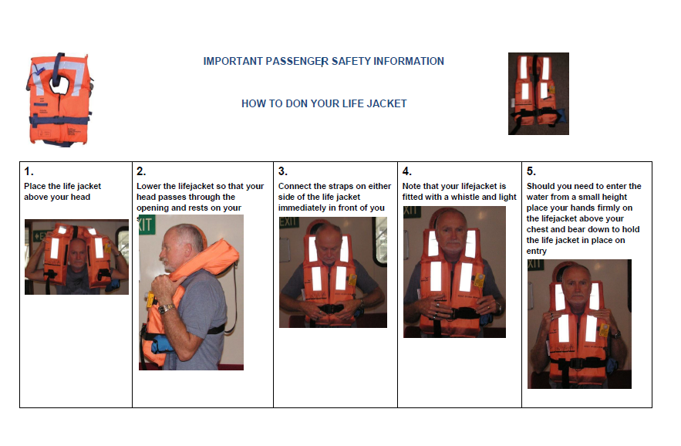
EMERGENCY ASSEMBLY STATION
- The Emergency Assembly Station for the vessel is the cockpit. In the event of danger in or near the cockpit, the alternate assembly station is the stern.
- Crew are to muster at Emergency Assembly Station in the event of an Emergency.
- Master or delegated person must account for all persons and conduct a search of vessel if persons are not visible or accounted for.
- Follow any instruction given by the Master or delegated person and provide assistance as required.
- Whenever the Vessel is in operation, all persons on board must be listed in the Vessel Log. The Vessel Log must be kept in an easily accessible location on board the Vessel.

EMERGENCY SITUATIONS
Situation |  | Emergency Response
Medical Emergency and Personal Injury |  | - Monitor health and safety of persons on-board  - Administer appropriate first aid to the patient  - Call for assistance via a PAN PAN or by phone 000 if situation cannot be managed safely on board  - Request shore contact to pre-arrange emergency medical services upon return to the shore
First Aid Response | D ANGER | Assess the situation, Ensure the safety of yourself, others & the patient. Remove the patient carefully from the water if required
 | R ESPONSE | Check for response (ask name, squeeze shoulders),  Response Make comfortable, monitor & treat secondary first aid issues  No Response – PAN PAN/Mobile Phone - 000
 | S END FOR HELP | PAN PAN / Mobile Phone - 000
 | A IRWAY | Open mouth, if foreign material present place in recovery position and clear the airway.
 | B REATHING | Check for breathing (Look, Listen, Feel)  Normal breathing Recovery position & monitor.  NOT breathing normal
 | C PR | Start CPR (30 Compressions : 2 Breaths)  Continue until help arrives or patient recovers
 | S ECURE | Secure patient and transport back to port if required, in consultation with medical professionals.  Record observations, injury and treatment details on the “Vessel Log”, and provide to medical professionals
Master Incapacitated |  | - Another person aboard must take control – preferably one with boating experience  - Assess situation, is the vessel in imminent danger?  - If the vessel is underway stop the vessel by placing the throttles in the neutral position  - Tend to the Master with first aid - DRABCD  - Follow emergency communication procedures to contact emergency services, Mayday if in imminent danger, PAN PAN if not in imminent danger or dial 000 on a phone. Try to work out the location of the vessel to tell emergency services  - Follow the directions of emergency services  - If the vessel is drifting near the shore deploy the anchor as told in the briefing  - If the vessel is drifting at sea and you cannot drive it deploy the sea anchor as explained in the procedures  - Attend to the well-being of the master and any other injured people  - Navigate to nearest safe wharf depending on the needs of the incapacitated person
Fire |  | - Master or delegated person to assess the situation and take action.  - Turn Vessel into the wind to minimize spread of fire (if possible).  - Shut down Engines  - Turn off Fuel supply (if possible) to main engines by closing all fuel shut off valves.  - Turn off Battery switches (if possible).  - Use Fire Extinguisher and attempt to put out fire if safe to do so  - Issue PAN PAN  - Monitor Fire  - Assess the damage, call for assistance or return to safe haven.  - If vessel is in danger if being engulfed prepare to ABANDON SHIP  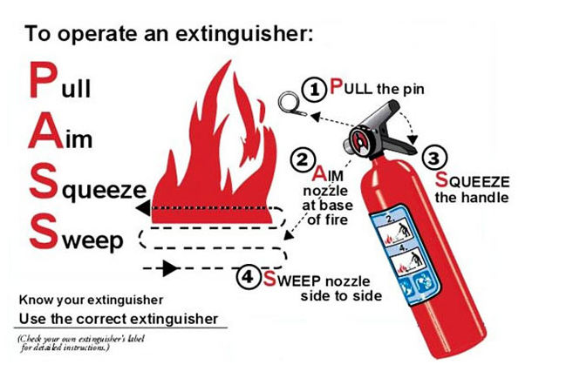
Loss of steering |  | - Assess the situation  - Direct all personnel to put on lifejackets  - Confirm the stability and integrity of the vessel  - If the vessel is drifting near to shore deploy the anchor  - If the vessel is drifting at sea deploy the sea anchor  - Are both engines not operational? Can you return to a safe haven on the one engine?  - If you cannot establish enough propulsion to safely move the vessel to a safe haven call emergency services for assistance.  - While waiting for assistance fly the V-sheet to alert other vessels and help the identification of your vessel
Person Overboard |  | - Whoever sees the incident shouts “Overboard, overboard, overboard”  - This person then maintains a visual watch of the person and keeps one arm pointing at the person or where the person was seen to go over. Use a flashlight in poor visibility.  - Throw a buoyant object (life ring, life jacket, esky) to help mark the spot and assist the person in the water.  - Master pushes “MOB” button on GPS plotter to mark position.  - Turn the vessel and approach from downwind of the person in the water.  - Once close enough, shift to neutral and turn off engines.  - Recover the person from the water.  - Render first aid or commence Medical Emergency Procedure if required.
Note: They may have injured themselves in the fall when hitting the water and may have abdominal/chest injuries that may make breathing extremely painful. Caution should be exercised in their retrieval.
They may have water in their lungs. They could also have vomited and choked in the process. Unconscious people rescued out of the water should be handled with a minimum of manipulation, have their airways cleared and respiration checked. If a pulse it is not present or detected and it is safe for participants, CPR should be commenced
Abandon Ship |  | In extreme situations it may be necessary to abandon the vessel for the safety of all personnel on board.  - The Master shall give the order to Abandon Ship.  - Account for all crew.  - Don Lifejackets, PLBs and warm / protective clothing.  - Switch off engines.  - Secure emergency equipment (EPIRB, flares, portable radio, knife, rescue mirror, sea dye marker, compass, portable GPS, water, food, first aid).  - Radio “MAY DAY”  - Throw Life Ring.  - Abandon Ship to Life Ring.  - Secure and activate EPIRB/PLB.
Collision |  | - Account for all crew.  - Check on the other vessel (if applicable) and crew.  - Check for injuries, render first aid or initiate the Medical Emergency Procedure if required.  - Assess and survey the damage.  - Decide on course of action i.e. continue with fishing operations, cease operation and return to port or contact emergency services.  - Activate bilge pump if required.  - Issue PAN PAN call if necessary.  - Escalate to Abandon Ship if necessary.
Vessel Grounding |  | - Account for Crew.  - Provide First Aid as required.  - Check for damage, flooding.  - Activate bilge pump if required.  - Determine appropriate action: keep working, return to safe haven or call for assistance.  - Issue PA PAN call if appropriate.  - Escalate to Abandon Ship if necessary
Vessel flooding( including sinking, flooding or capsizing) |  | - Raise the Alarm  - The Master shall give directions.  - Don Lifejackets, grab EPIRB & ready emergency grab bag (safety equipment).  - Activate bilge pumps and / or manual pumps / bailers.  - Attempt to stop the leak or reduce the flow.  - Navigate to a safe location if possible.  - Issue PAN PAN / call for assistance as required.  - Escalate to Abandon Ship if necessary.
Adverse weather or water |  | - Secure the load in a manner that will give the best vessel stability for the prevailing conditions.  - Don Lifejackets /PFD’s and warm / protective clothing.  - Ready Life Ring & emergency equipment.  - Plot appropriate course to shelter / safest route.  - Consider use of a sea anchor.  - Radio Marine Police/Coast Guard/other vessels/onshore radio operators to update current location and course details.
Spill ( fuel or chemical) |  | - Deckhand must notify the master immediately  - Find the source of the spill and contain it  - Minimize the spread of the pollutant Note what time and the location that the spill was first discovered on the log book  - Notify the Regulatory Authority immediately
Retrieval of a person from a restricted space |  | - Assess the situation and the nature and severity of the injured / unconscious person  - If the person can be left in the engine room and needs medical assistance transmit ‘PAN PAN” call or use a mobile phone call to attract attention of other local vessels and wait for instructions/ assistance  - If the person must be removed from the engine room turn the engine off ,if required and if safe to do so  - Assess entry to engine room if safe to do so  - Upon entry ( if applicable)Undertake DRABC procedures  - Crawl into the engine room and lift the person out of the engine room OR  open hatch in the corner and lift person out  - Transmit ‘PAN PAN” call or VHF/mobile phone call to attract attention of other local vessels;  - Wait for assistance or secure the victim in a safe position with hearing protection and steam to the closest port to gain medical assistance.  - The rescue procedure shall be included in the emergency drills for the vessel.
Launching life raft |  | - Check the painter (the rope) is fastened on board;  - Operate hydrostatic release and remove securing strap;  - Check that water below is clear and throw life raft over the side;  - Firmly pull painter (the rope) for inflation;  - Pull alongside main vessel;  - If necessary, put one person in water to turn over life raft;  - May need to ventilate the life raft for 1 minute to allow gas to escape prior to entry  - NOTE: that it may not be possible for one person to turn over life raft after its painter has been cut free. It is however preferable that all crew board the life raft dry, that is without having to enter the water. Do not delay, unnecessarily, in boarding the life raft once it is inflated.  - Ventilate the raft for 2 minutes to allow gas to escape prior to entry  - Board the life raft and when all persons are on board, cut the painter and paddle away from vessel;  - Stream sea anchor;  - Ensure EPIRB is activated and establish communications with rescuers if possible;  - Post lookout and arrange watchers;  - Take sea sickness tablets whether required or not; and  - Follow survival techniques.
The best response to the diving emergencies is often determined by the specific circumstances. Diver and Deckhand MUST make use of their experience and personal judgement to determine the safest course of action.
Diving injury(Suspected DCI, or Baratrauma) |  | Symptoms  - Pain (often around joints  - Numbness & Tingling  - Weakness / Paralysis  - Altered Responsiveness  - Breathing, Vision or Speech Difficulty  Treatment  - Lay the Diver Down Flat  - Provide Basic Life Support (see Medical Emergency)  - Provide as Near to 100% Oxygen as Possible  - Call Emergency Services
Shark Attention |  | - Diver to seek cover on the reef.  - Attempt to establish communication signals between diver and crew.  - Endeavour to have the boat directly above the diver.  - Diver to surface when safe to do so.  - Deckhand to assist Diver into the boat.
Out of Air (Airline cut, Compressor failure, and other urgent) |  | - Deckhand turns on air reserve if available (for compressor failure).  - Deckhand signal diver to surface immediately.  - Deckhand to assist Diver into the vessel.  - Assess the situation and take appropriate action.
Anchor Drag, Severe weather approaching, and other non-urgent) |  | - Deckhand signal diver to surface as soon as practical.  - Diver to surface when ready.  - Deckhand to assist Diver into the vessel.  - Assess the situation and take appropriate action

Appendix 2: Dangerous Species First Aid
DANGEROUS SPECIES FIRST AID
Species | Immediate First Aid  (for more information on specific incidents, contact the listed Emergency Contact) | Emergency Contact
Snakes  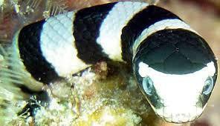  Sea snake  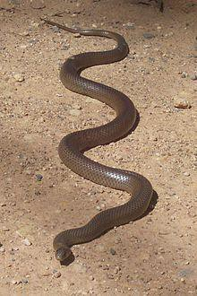  Eastern brown snake | Apply the pressure-immobilisation technique as per below:  For bites on the limbs  - Immobilise the affected limb  - Wrap a pressure bandage around the affected area  - Bandage upwards from the lower portion of the bitten limb  - Bandages can be created from any material such as clothing, towels etc. that can be torn into strips  - Do not remove any of the person’s clothing as the additional movement will increase the circulation of venom within the blood stream  - The bandage should be as tight as you would apply to a sprained ankle  - Keep the patient still  - Do not cut into the bitten area  - Do not apply an arterial tourniquet. (these are potentially dangerous)  - Do not wash the bitten area  - Any venom left on the skin may assist with identification of the snake and the resultant treatment  For bites on the torso  - If possible apply firm pressure over the bitten area.  - Do not restrict chest movement  - Keep the patient still  - Refer immediately to a hospital for emergency treatment  For stings on the head or neck  - No first aid is to be applied to the bite  - Keep the patient still  - Refer immediately to a hospital for emergency treatment | Call 000  Or  24 Hr. Service Poisons Information Centre 131126
Sea Urchins  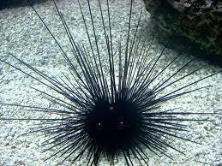 | - Soak the affected area in hot but not scolding water for up to 90 minutes to help relieve the pain.  - Do not apply hot water if the person is an infant, very elderly, or suffers from a poor skin condition  - Refer immediately to a hospital for emergency treatment if the patient has received a deep wound or if pain persists | Call 000  Or  24 Hr. Service Poisons Information Centre 131126
Fire Sponges | - Wash the affected area with water  - Refer patient to the nearest medical centre or hospital if the patient is unwell or presents with symptoms such as reddening or blistering of the skin | Call 000  Or  24 Hr. Service Poisons Information Centre 131126
Box Jellyfish  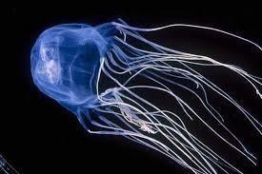 | - Douse the tentacles with vinegar  - Apply ice packs  - Do not try to remove the tentacles  - Do not rub the vinegar into the affected area | Call 000  Or  24 Hr. Service Poisons Information Centre 131126
Irukandji Jellyfish  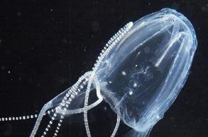 | - Irrigate the site with water  - Douse with vinegar  - Refer patient to the nearest medical centre or hospital if pain persists | Call 000  Or  24 Hr. Service Poisons Information Centre 131126
Other Jellyfish | - Remove any tentacles by washing with water  - Apply ice packs to relieve the pain  - Refer patient to the nearest medical centre or hospital if pain persists | Call 000  Or  24 Hr. Service Poisons Information Centre 131126
Stone Fish, Lion Fish, Scorpion Fish  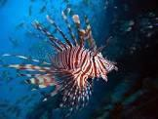 | - Wash the wound immediately  - Soak the affected area in hot but not scolding water for up to 90 minutes to help relieve the pain.  - Do not apply hot water if the person is an infant, very elderly, or suffers from a poor skin condition  - Do not apply- pressure-immobilisation technique  - Refer immediately to a hospital for emergency treatment and administering of the antivenom | Call 000  Or  24 Hr. Service Poisons Information Centre 131126
Stingray  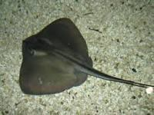 | - Wash the wound immediately  - Soak the affected area in hot water for up to 90 minutes  - Apply local pressure for bleeding  - Resuscitate if there are thoracic or abdominal injuries | Call 000  Or  24 Hr. Service Poisons Information Centre 131126
Happy Moments and John Dory  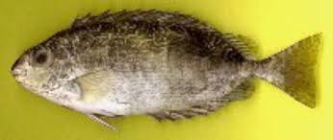  Happy Moments  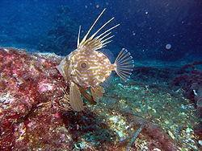  John Dory | - Soak the affected area in hot but not scolding water (ideally 45C) for up to 90 minutes  - If the sting has caused a deep wound, or other symptoms are present, the patient should see their local doctor  - Do not apply hot water if the person is an infant, very elderly, or suffers from a poor skin condition | Call 000  Or  24 Hr. Service  Poisons Information Centre 131126
Other stinging fish:  - Cobbler  - Catfish  - Flathead | - Soak the affected area in hot but not scolding water for up to 90 minutes to help relieve the pain.  - Do not apply hot water if the person is an infant, very elderly, or suffers from a poor skin condition  - Refer patient to the nearest medical centre or hospital if the patient has received a deep wound or if pain persists | Call 000  Or  24 Hr. Service Poisons Information Centre 131126
Sharks  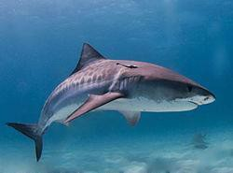 | - For minor wounds (from small sharks) where the skin is barely broken: Wash and clean the wound with soap and water, apply an anti-biotic agent and cover with a bandage. | Call 000
Severe wounds | - Get the patient out of the water as soon as it is safe to do so.  - Try to keep them warm.  - Manage bleeding as an absolute priority: apply pressure with a clean, dry cloth to stop the bleeding.  - Lost limbs should be retrieved if possible and brought with the patient to hospital for assessment of viability.  - If the person has cool and clammy skin, weak and rapid pulse, is faint or unconscious, apply shock treatment below:
Shock Treatment | - Lay the person down if possible. Elevate their feet about 300 mm unless head, neck or back is injured or you suspect broken hip or leg bones. Do not raise person’s head. Turn them on their side if they are vomiting or bleeding from the mouth.  - Begin CPR if they are not breathing. Check breathing every five minutes until help arrives.  - Keep person warm and comfortable. Loosen restrictive clothing. Cover with coat or blanket. Keep the person still. Do not move them unless there is danger. Reassure them. Do not give anything to eat or drink.

CHECKLISTS

Appendix 3: Pre-Departure Checklist- and scheduled maintenance
Scheduled inspection | Description | Responsibility | Scheduled inspection | Description | Responsibility
 |  | Master |  |  | Master
Navigation and Communications | Radar |  | Bilge and Fire Pumps | Main and secondary pump
 | Satellite Navigation GPS |  |  | Bilge Manifolds/Valves
 | Compass Magnetic |  |  | Bilge Strainers
 | Helm and Associated Controls |  |  | Submersible bilge pump
 | VHF Radio |  |  | Fire Pump Sea water inlet valve
 | Navigation Lights |  |  | Main fire power pump
 | Horn
Emergency Alarms | Fire Detection |  | Vessel hull | Visual hull inspection
 | Oil Pressure and level |  |  | Bungs
 | Oil temperature |  |  | Transom
 | Fuel Pressure |  |  | Bimini secure
Propulsion machinery and associated systems | Main engine |  |  | Anchor line secure
 | Gear box
 | Oil level |  | Steering Gear | Hydraulic Lines and Fittings
 | Fuel tanks and gauges |  |  | Steering Rams and seals
 | Fuel capacity |  |  | Emergency steering
 | Fuel lines and emergency shut off valves |  |  | Rudder Bearings
 | Exhaust line and D/O Valve |  |  | Ridder Stops
 | Batteries( Main, Emergency and radio)
Outboard and Fuel | Outboard secure to transom and safety lanyard |  | Compressor , diving equipment and air delivery system( if applicable) | Compressor engine service
 | Fuel tank visual, no leaks and fuel lines okay |  |  | Air pump – service
 | Fuel tank secure to hull |  |  | All hose fittings – Inspect, tighten
 | Adequate fuel |  |  | Breathing Air Filters - Inspect
 | Fuel line securely fitted to outboard |  |  | Air Receiver - Inspect
 | Propeller okay and secure |  |  | HP Reserve cylinder – service
 | Engine run test and cooling water check |  |  | Dive Hose – test
 |  |  |  | Dive Regulator
 |  |  |  | Bail Out cylinder

Appendix 4: Pre-Departure Checks
Scheduled inspection | Description | Responsibility | Scheduled inspection | Description | Responsibility
 |  | Crew |  |  | Crew
Lifesaving Appliances | Buoyant Appliance ( 1 x 4 man) |  | Miscellaneous | Torches x 2 (test)
 | Life jackets- easily accessible |  |  | Two oars
 | Lifebuoy x 1 with light |  |  | Anchor, chain and line
 | Lifebuoy x 1 with buoyant line |  |  | Emergency procedure sin wheelhouse contacts
 | Heaving line with rescue quoit x 1 |  |  | Air horn
 | PFD’s |  | Other | Toilets clean and equipped with hand wash, paper towel and toilet paper
 | Life ring with light
 | First Aid kit |  |  | Fresh water tanks full
 | EPIRB
Distress Signals | Parachute rocket x 3 |  |  | Sewage and grey water tanks
 | Red Hand held flares x 2 |  |  | Compartment bilges
 | Handheld orange smoke signal x 1 |  |  | Gangway
Fire fighting | Machinery space ventilation shut offs |  |  | Anchor and windlass
 | Machinery space fixed fire smothering system |  |  | Hatches and closing devices
 | Fire hose and nozzle x 1 |  |  | Doorways and closing devices
 | 4.5 Kg dry chemical extinguishers |  |  | Windows and closing devices
 | Fire blanket x 1
 | Fire bucket x 1
Communication | Test of VHF radio
 | Mobile phone check (on battery life and waterproof case)

Appendix 5: Maintenance Log
Date | Maintenance conducted | Name / initials

Appendix 6: Crew Induction checklist
Crew member name: |  | Confirm
Item
 | Vessel safety management system(SMS)
 | Vessel familiarisation
Safety Equipment – where is it and how to use it
 | Life jackets location/try on
 | Personal flotation devices /location and try on
 | Life raft
 | Flares
 | EPIRBS
 | Fire extinguisher
Operational safety
 | Fire hoses
 | Fixed fire fighting
 | Fuel shut off valves
 | All water tight doors
 | Fire flaps
 | Embarking and disembarking the vessel
 | Personal protective clothing and equipment
 | Vessel operating controls
 | Navigation equipment
 | Radio communications equipment
 | Radio communications emergency procedure
 | Vessel operating system alarms
 | Manoeuvring at berth
 | Emergency stop procedure
 | Voyage planning
 | Charts and safe navigation
 | Anchor deployment and recovery
 | Lookout duties
 | Voyage pre-departure checks
 | Electrical installations
 | Fuel system
 | Fire and bilge pumps
 | Steering gear and emergency steering
 | Watertight subdivision and integrity
 | Compressor checks
 | Cylinder checks

Appendix 7: Master/ Crew training register
Master /Crew name | Vessel Induction date | Master 5 | Coxswain | First aid HLTAID003 | First Aid expiry | Other

Appendix 8: Approved Crew List
MASTER/ CREW DETAILS
Name | Address | Contact Details | Next of Kin | Next of Kin Contact | Date Joined vessel | Date Left vessel

Appendix 9: Emergency drill record
RECORD OF DRILLS
Name | Drill type( date conducted) |  |  |  |  |  |  |  |  | Master Signature
 | Fire | Man overboard | Abandon ship | Flooding | Grounding | Collision | Medical Emergency | Master incapacitated | Severe weather

Appendix 10: Vessel logbook
Vessel log book [Insert Vessel Name]
Date: |  | Activity |  |  |  | Operating area: |  |  |  |  |  | Departure time:
Pre departure checks conducted |  |  |  |  |  |  |  |  |  |  | Crew complement
Master |  |  |  |  |  |  | Crew |  |  | Crew |  |  |  | Crew
Yes No |  |  |  |  |  |  | Yes No
Master’s comments |  |  |  |  |  |  | Crew comments
Weather conditions / sea state encountered
Weather / sea state:

Vessel log book
Vessel running sheet including any maintenance issues)
Incidents, accidents, medical emergencies
Radio communications |  |  |  |  |  |  |  | Incidents
Messages sent |  |  | Messages received |  |  |  |  | Other
Time | Details |  | Time | Details |  |  |  | Time | Details |  | Time |  | Details

Appendix 11: Incident Register
Date | AMSA  Report() | Worksafe WA report() | Environment  () | Details | Action Taken | Master Signature

Appendix 12 Revisions & Annual Review Page
Date | Revision made | Signature of person making the change.

